|  |  |
| --- | --- |
|  | **Eastern Goldfields College**Yr 11 Essentials MathematicsStatistics Investigation 2019 **Name: _____________________________________** |
| Working Time: 4 Periods | **CALCULATORS ARE ALLOWED** Total Marks: 74 |

“The Average Student”

You have been asked to collate, analyse and interpret a sample of data taken from the *CensusAtSchool* site.

The data has been organised into two summary sheets. These are the categorical data and numerical data summary sheets. **Decide which sheet is which before you start your tasks.**

In order to describe the “AVERAGE” student we need to calculate some statistics and collate some data related to physical attributes of these students, what these students do and what they like.

CATEGORICAL DATA

Use the data provided to answer the following questions.

1. Complete the table below for birth month. (4 marks)

|  |  |  |
| --- | --- | --- |
| **Month** | **Tally** | **Frequency** |
| January |  |  |
| February |  |  |
| March |  |  |
| April |  |  |
| May |  |  |
| June |  |  |
| July |  |  |
| August |  |  |
| September |  |  |
| October |  |  |
| November |  |  |
| December |  |  |
|  |  |  |

2. Draw a suitable graph to display the birth months for the 80 students. (5 marks)



3. What is the modal birth month? (1 mark)

4. What percentage of students were born after June 30? (2 marks)

5. What fraction of students were born in January? (1 mark)

6. Which month were the fewest students born? (1 mark)

7. Construct a dot plot to display “Favourite Take Away Food” (4 marks)



8. What is the most popular take away food from the data presented? (1 mark)

9. Which food is the least popular amongst the students? (1 mark)

10. The percentage of students who said chips was their favourite is twice the percentage of those who said hamburgers was their favourite. (1 mark)

TRUE or FALSE

11. What is the % difference between the most popular and least popular take away food? (2 marks)

12. Complete the following frequency tables for the remaining data. (9 marks)

|  |  |  |
| --- | --- | --- |
| **EYE COLOUR** | **TALLY** | **TOTAL** |
| Blue |  |  |
| Brown |  |  |
| Hazel |  |  |
| Green |  |  |
| Grey |  |  |
| Other |  |  |
|  |  |  |

The most common eye colour is _________________

|  |  |  |
| --- | --- | --- |
| **HOW TRAVEL TO SCHOOL** | **TALLY** | **TOTAL** |
| Car |  |  |
| Walk |  |  |
| Bus |  |  |
| Train/Tram |  |  |
| Bicycle |  |  |
|  |  |  |

The most common method of travel to school is __________________

|  |  |  |
| --- | --- | --- |
| **FAVOURITE SPORT** | **TALLY** | **TOTAL** |
| Football (Soccer) |  |  |
| Football (AFL) |  |  |
| Football (Rugby) |  |  |
| Basketball |  |  |
| Athletics |  |  |
| Swimming |  |  |
| Netball |  |  |
| Dancing |  |  |
| Cycling |  |  |
| Cricket |  |  |
| Tennis |  |  |
| Martial Arts |  |  |
| Gymnastics |  |  |
| Baseball/Softball |  |  |
| Hockey |  |  |
| Other |  |  |
| None |  |  |
|  |  |  |

The most popular sport is ____________________

NUMERICAL DATA

Use the data provided to complete the following:

Complete the frequency table below for time taken to travel to school. (4 marks)

|  |  |  |
| --- | --- | --- |
| **Time in minutes** | **Tally** | **Frequency** |
| 0 – 15 |  |  |
| 15 - 30 |  |  |
| 30 – 45 |  |  |
| 45 – 60 |  |  |
| 60 – 75 |  |  |
| 75 – 90 |  |  |
| 90 – 105 |  |  |
| 105 – 120 |  |  |
| **\*\*0 – 15 means more than 0 up to and including 15** | |  |

1. Construct a histogram for the time taken for the students to travel to school. (4 marks)



1. Describe the distribution of your histogram. (2 marks)
2. State the time of the slowest and quickest student and hence calculate the range of the

time taken for students to travel to school. (2 marks)

1. Calculate the mean time taken by the students. (2 marks)
2. What percentage of students took between 0 and 30 minutes to travel to school?

(2 marks)

1. Why is a histogram a good way to display this data? (1 mark)

7. Compare the hours spent on homework to the hours spent on video games by completing a five number summary for each and then constructing two ‘box and whisker plots’ on the grid below. (10 marks)

Use the space below for working.

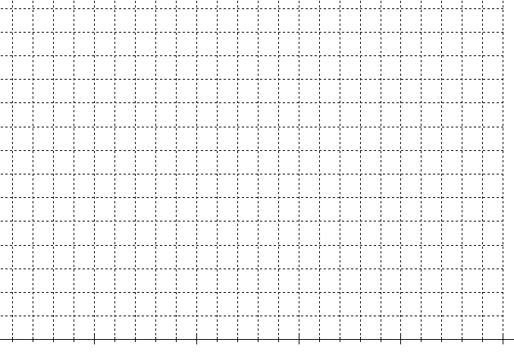

1. What is the interquartile range for the hours spent on homework? (1 mark)
2. Which set has a greater standard deviation? How do you know? (2 marks)
3. 25% of students spend more than 10 hours on video games

TRUE or FALSE (1 mark)

1. Consider students 12 and 43.
2. What is the difference in their week’s pay? (1 mark)
3. What is their height difference? (1 mark)
4. Student 43 takes twice as long to get to school as student 12.

TRUE or FALSE (1 mark)

1. What is the range of **all** the student heights?
2. Is there an outlier(s) (1 mark)
3. How do you know? Justify your answer with calculations. (2 marks)
4. Draw a stem and leaf display for the heights of the students. (Remove any outliers in the data first) (3 marks)
5. Using the statistics you have calculated describe the “Average Student” (2 marks)

END OF INVESTIGATION